Safe work method statement
Job Task Summary:  Beef program | This SWMS is applicable to the following worker type: |  | employee | contractor | volunteer
Job Task Summary:  Beef program |  |  | student | visitor | other
Job Task Summary:  Beef program | SWMS completed by: |  | (Name)
Job Task Summary:  Beef program | Site: |  | (Name)
Job Task Summary:  Beef program | Date: |  | (Name)
How to complete the form:  - Discuss with relevant workers the steps, and associated hazards, risks and controls  - In the ‘Procedural steps’, list the work steps in sequence of how they will be carried out  - In the ‘Possible hazards’, list the hazards and risks for each step  - In ‘R1’ rate the risk without controls using the risk matrix (see over page) |  | - In the ‘Safety controls’ list how the hazards will be controlled and who is responsible to implement the controls  - In ‘R2’ rate the risk with controls (residual risk) using the risk matrix (see over page)  - Specify other requirements for the task  - Each person involved with this task must sign acknowledging that they have understood the steps

R1 Risk without controls R2 Risk with controls
PROCEDURAL STEP(S) | POSSIBLE HAZARD(S) | R1 | SAFETY CONTROL(S) | PERSON RESPONSIBLE | R2
Alight students from transport and gather near cattle yard | - Vehicle collision | 2C | - Students kept together  - Students under supervision of EEC staff or directed school staff at all times. | EEC teacher in charge of activity
Students movement around and through yards | - Tripping/falling hazards  - Overhead hazards  - Collision with cattle  - Jamming hazards of gates and crush | 3D | - Students warned of tripping and overhead hazards  - Students directed (ie. always accompanied)  - Unnecessary tripping hazards removed  - Demonstrate correct use of yard equipment | Teacher in charge of activity  EMAI staff
Students move cattle through yards and race | - Zoonotic diseases  - Kicked by cattle  - Collision with cattle | 3D | - Students warned of potential risks  - General warning for pregnant/unwell (higher risk) visitors  - Students instructed on best practice for cattle mustering/movement. One to three teacher:student supervision max  - Cattle with poor temperament identified and avoided  - No student or teacher to enter race with cattle. Students under direct supervision of EEC staff at all times around crush. | Teacher in charge of activity  EEC Admin staff  Teacher in charge of activity  EMAI staff  Teacher in charge of activity  Teacher in charge of activity
Moving students around farm | - Vehicle collision  - Snake bite  - Tripping  - Dehydration |  | - Keep students together and under direct EEC supervision.  - Do not gather students on blind sections of internal road ways.  - Transport students as close as possible to site.  - Warn students of snake risk  - EEC staff to carry snake bite first aid kit including pressure bandage  - Warn students of tripping hazards and move students through paddocks in a controlled way.  Ensure students have access to water when completing task in Summer months. | Supervising EEC teacher
Student-directed learning activities | - Insect bites/stings  - Cattle trampling  - Students become lost  - Grass and other allergies |  | - Warn students of hazard  - Activity not to be undertaken in immediate vicinity of cattle  - Maintain visual contact with students at all times. Stipulate working areas (boundaries) and adopt roving supervision  - Check school-provided information re. allergies and Action Plans. Restrict student participation if appropriate after consulting visiting teacher(s) | Supervising EEC teacher and visiting staff

WHS RISK MATRIX | HIERARCHY OF CONTROLS
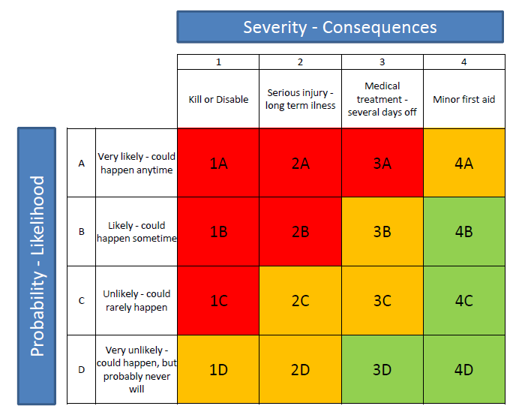 | 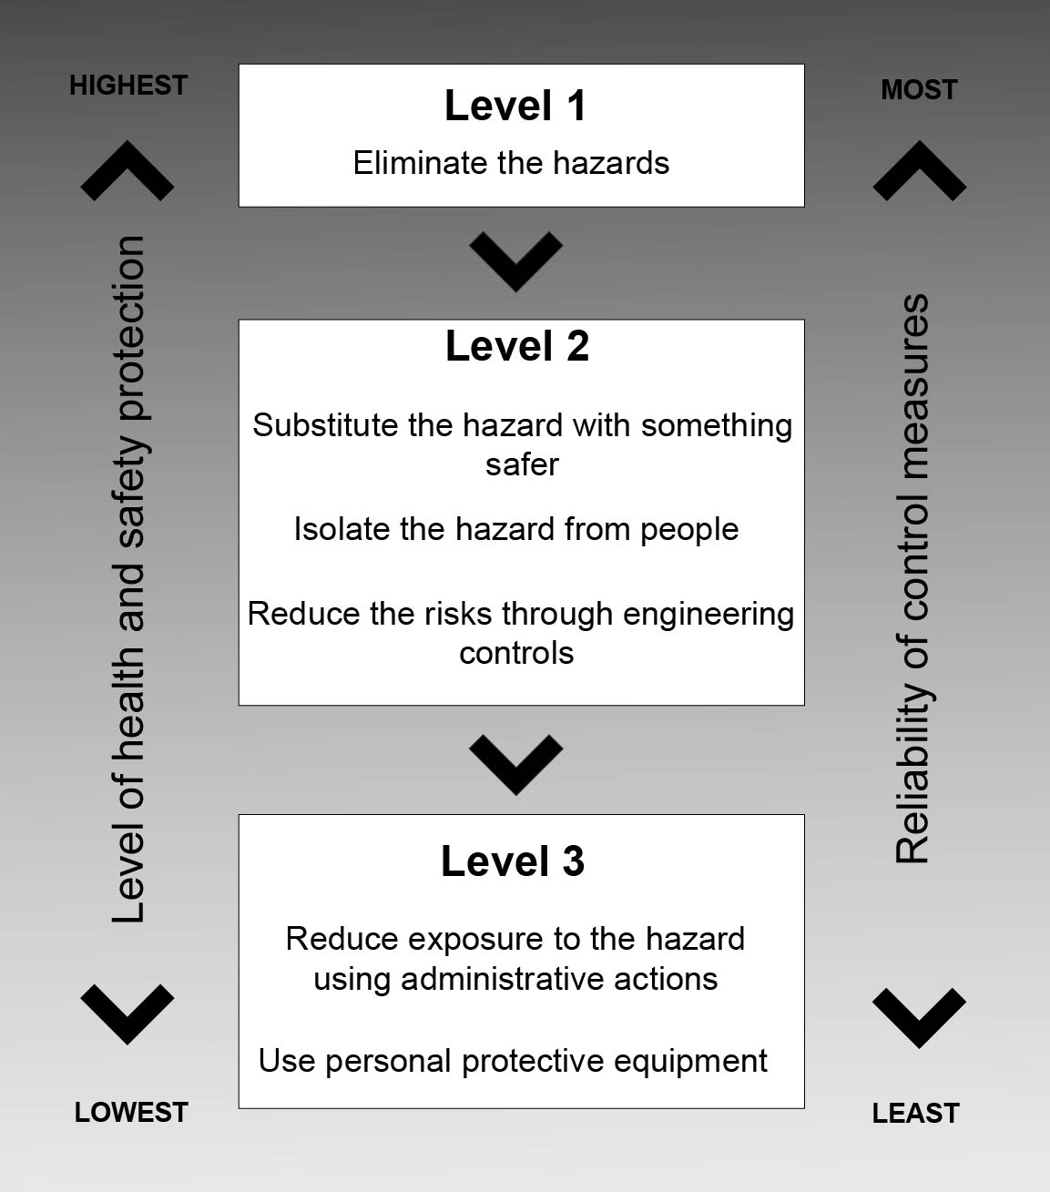

OTHER JOB REQUIREMENTS

