Pasture Production at Elizabeth Macarthur Agricultural Institute (EMAI)
At EMAI, as with most Australian beef cattle farms, pasture production is the basis of the meat production enterprise. Pastures provide the cheapest source of nutrition for beef cattle. Hence, the production of high quality pastures which remain productive throughout the year is a prime goal for Australian dairy farmers. EMAI two distinct pasture production systems are in existence.
- Unimproved pastures.
These are found on land classed as class 4 and above. They are composed of native species and naturalised species. The most prominent native species are:
- Kangaroo Grass (Themeda triandra) http://www.pasturepicker.com.au/Html/Kangaroo_grass.htm
- Common Wallaby Grass (Austrodanthonia caespitosa) http://www.pasturepicker.com.au/Html/Wallaby_grass_(Austrodanthonia_caespitosa).htm
- Umbrella Grass ( also known as Windmill Grass) (Chloris truncata) http://www.agric.wa.gov.au/objtwr/imported_assets/content/past/windmill%20grass.pdf
The most prominent naturalised species are:
- Rhodes Grass (Chloris gayana ) http://www.pasturepicker.com.au/Html/Rhodes_grass.htm
- Paspalum (Paspalum dilatatum) http://www.iewf.org/weedid/Paspalum_dilatatum.htm

These unimproved pastures are of relatively low nutritional value, grow actively only in the warmer months and are of low productivity in comparison to the improved pastures. They do, however, grow well on poor soils and are quite drought tolerant. For this reason they are not used for the main herd but rather for the dry cows where large amounts of energy and protein are not required by the cows.
These pastures are fertilised with superphosphate a rate of 20 kg/has each two years to help maintain their productivity. Care is also taken to ensure that they are not overgrazed as native grasses do not persist well under intensive grazing pressure.

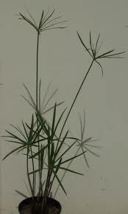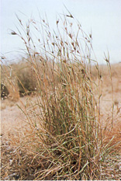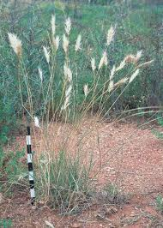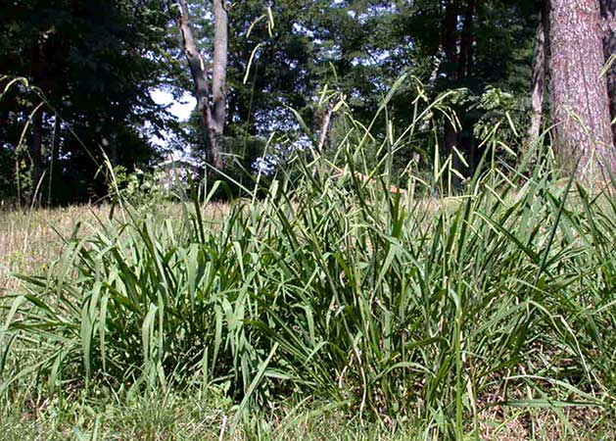
Windmill grass Kangaroo Grass Common wallaby Grass Paspalum
- Improved pastures
Improved pastures are grown on the higher class land that exists on the creek and river flats on the farm. The soils here are deep and relatively fertile and the topography makes irrigation of the pastures in times of low rainfall possible. This, combined with the judicious use of artificial fertilisers, maintains high productivity from these pastures throughout the year.

Three species are used in these pastures.
- Kikuyu (Pennisetum clandestinum) http://www.pasturepicker.com.au/Html/Kikuyu.htm
- Perennial Ryegrass (Lolium perenne) http://www.pasturepicker.com.au/Html/Perennial_ryegrass.htm
- White Clover (Trifolium repens) http://www.pasturepicker.com.au/Html/White_clover.htm

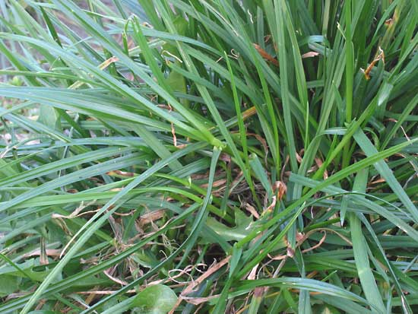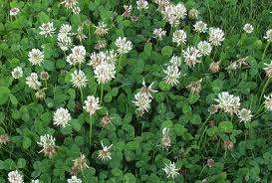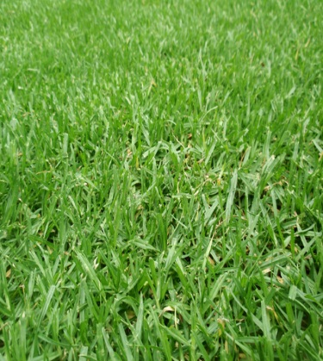
Perennial Ryegrass White clover Kikuyu
The kikuyu, being a warm season grass, provides the basis of pasture production from mid spring until mid autumn. The perennial ryegrass and white clover, being cool season species, are then direct drilled into the existing kikuyu pasture to provide winter feed for the herd. You can see an example of the use of direct drilling here:
http://www.youtube.com/watch?v=0xx1kyn31wU

Chemical fertilisers are applied to these pastures as follow:
Fertiliser type | Nutrients supplied | Application rate | Timing
Hi-Fert blend (15:8:6) | N, P K | 150 Kg/ha | Spring
Urea | N only | 100Kg/ha | After each 2nd grazing

Grazing strategy
The pastures are intensively grazed using a rotational grazing strategy. The farm is divided into a number of paddocks with permanent fencing. Production from these pastures is approximately 20 tonnes of dry matter per hectare per year.
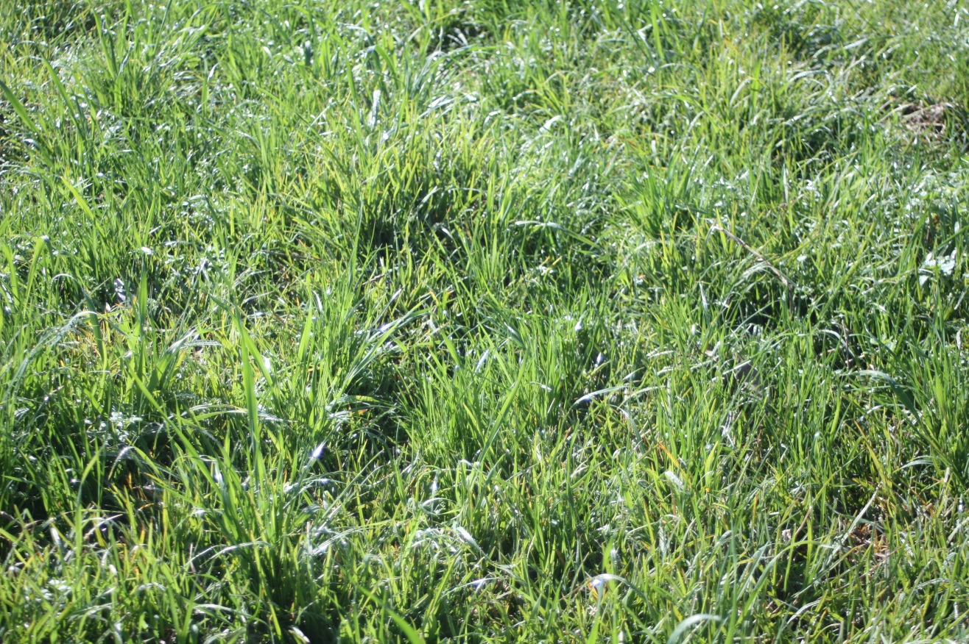
Actively growing sod-seeded ryegrass

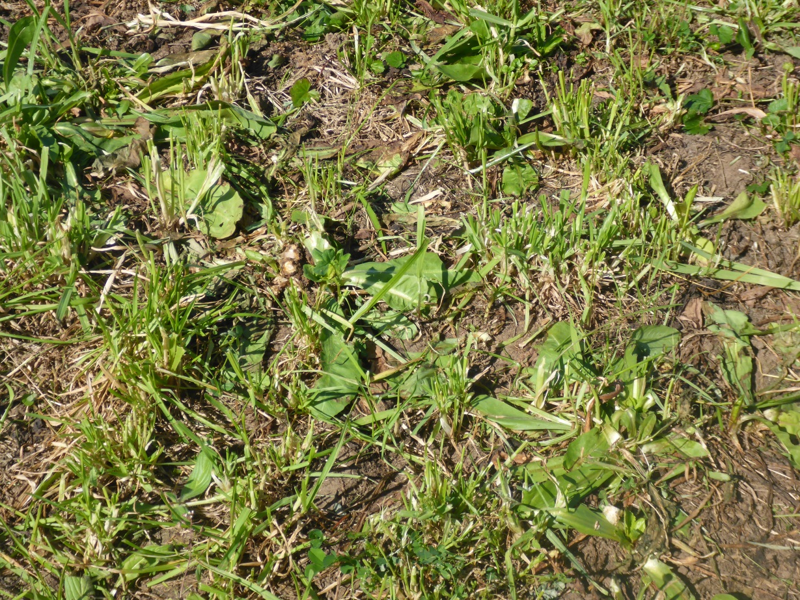
Recently grazed ryegrass pasture
Weeds in pastures
The major issues associated with weeds growing in pastures include:
- reduced pasture productivity due to competition from weeds
- some weeds are potentially poisonous to livestock
- some weeds can taint milk, meat or eggs, leaving them with an undesirable taste and /or smell
- the seeds of some weeds contaminate products such as wool and meat
- some weeds can physically harm livestock as a result of having spines on them or having spiny seeds or fruits
- contamination of fodder (hay and silage) made from the pasture
Several weed species grow in the pastures EMAI. They include:
Fireweed: this is an annual species that can cause poisoning in some animal species. Cattle generally avoid eating it. The major impact of fireweed on the farm is to reduce pasture productivity through competition for space, nutrients, water and light. You can find out more about fireweed here:
http://www.dpi.nsw.gov.au/agriculture/pests-weeds/weeds/profiles/fireweed
Spear Thistle: a large, spiky annual weed that cattle avoid eating. Again, their main impact is to reduce pasture productivity through competition. They also contaminate hay and silage. You can find out more about Spear Thistle here:
http://www.weeds.org.au/cgi-bin/weedident.cgi?tpl=plant.tpl&state=&s=&ibra=all&card=H71
Chilean Needle Grass: a tussock-forming, highly invasive perennial grass of low palatability that invades both native and improved pastures. It is considered as weed of national significance because of its ability to compete strongly with native and introduced pasture species. You can find out more about Chilean Needle Grass here:
http://www.environment.gov.au/biodiversity/invasive/weeds/publications/guidelines/wons/pubs/n-neesiana.pdf

At EMAI the chief means of reducing the impact of all three of these species is to maintain vigorous pasture growth throughout the year in an attempt to out-compete them and thus reduce their invasiveness. Chemical controls may be used as last resort when the level of pasture contamination by these weeds becomes excessive.

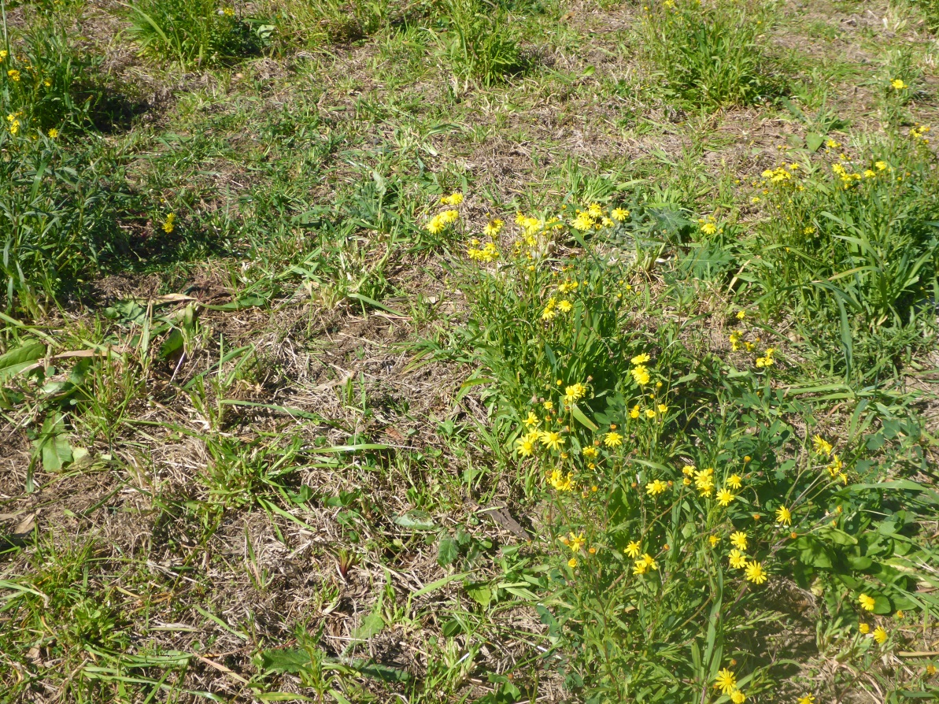
Fireweed in recently grazed pasture. Note how it has not been eaten.

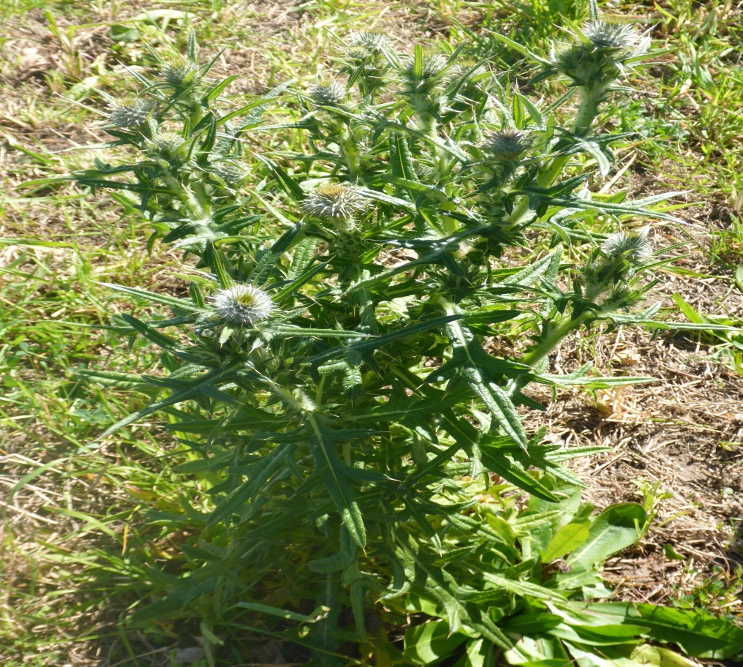
Spear Thistle in recently grazed pasture.
Activities for you to complete
- Construct a table like the one shown below.
Common name | Strengths | Limitations | Special features
Kangaroo grass

Wallaby Grass

Umbrella Grass

Paspalum

Rhodes Grass

Perennial Ryegrass

Kikuyu

White Clover

Enter the common name of the pastures species used on the farm into the left hand column of the table. Summarise the limitations and strengths of each species and note any special features of each one. Use the websites listed for each species (and any others you care to search out) to find your information
- Outline the reasons for the use of the fertiliser program described above.
- List the principal benefits of the rotational grazing system that is at EMAI.
- Construct a table like the one below.
Name of weed | Impacts on farm production | Control strategies available
Fireweed

Spear thistle

Chilean Needle Grass

Complete the table by summarising the impacts of each weed on farm production and the control strategies that are available to farmers for each one. Use the websites listed for each species (and any others you care to search out) to find your information

