Aboriginal history and land management at Elizabeth Macarthur Agricultural Institute (EMAI)
`The land on which EMAI now stands was occupied by the Cubbitch Bata people, a clan within the much larger Dharawal group who occupied land along the coastal strip south of Botany Bay down to the Shoalhaven River, and lands in the catchments of the Nepean, Georges, Nattai, Wollondilly and Cataract rivers. The Dharawal people referred to the land around Camden as Yandel’ora , which means the land of peace between peoples. This was a special place in Aboriginal culture because members of all the Aboriginal groups from Melbourne in the south to Maroochydore in the north met here to settle disputes, determine common laws and arrange marriages. There is evidence on the property of these meetings. Implements made from stone not found anywhere close to here have been found, indicating that they were brought here by clans from other areas of Australia.
Aboriginal people are thought to have inhabited the area for at least 50,000 years before European settlement in 1788. The first contact between the local Aboriginal group and the new settlers must have happened in the very early years of settlement by Europeans. The two bulls and four cows that escaped from the settlement at Port Jackson found their way to the Menangle-Camden area (which became known as “The Cowpastures”). Drawings of these animals have been discovered on the walls of a sandstone cave in the district.
There seems to have been little disputation between the local Aboriginals and white settlers until around 1810 when white settlement was becoming more intensive. A massacre at nearby Appin in 1816 resulted in the near annihilation of the Aborigines around Camden. Many also succumbed to diseases such as smallpox and influenza which they had not encountered before white settlement, meaning that they had little natural resistance to them.
Those Aborigines who survived the diseases and massacres retreated to an area south of the Nepean River and an area on John Macarthur’s Camden Park Estate was set aside for those Aborigines who wanted to live there. They were protected by the Macarthur family. Their number slowly declined, largely as a result of and influenza epidemic in 1820 and very few Dharawal people remained in the district by 1850.
The Dharawal people had developed a range of technologies to help provide them with food and shelter. These included:
- ”Firestick farming”, by which the grasslands were selectively burnt to encourage new growth. This in turn attracted herbivorous animals which were hunted for food and clothing.
- Planting yams, a plant that produces underground tubers in a similar way to potatoes.
- Trapping of fish and eels. There is evidence of this in several lagoons located on another part of the original Camden Park Estate
As with elsewhere in Australia, Aboriginal culture was handed from generation to generation by the tradition of storytelling. Special laws were in place regarding hunting near waterholes and during unseasonable conditions to ensure the survival of animals and plants into the future.
You can find out more about aboriginal inhabitation of the land around Camden where EMAI is located by looking at the following websites.

https://www.belgennyfarm.com.au/history/site-history
https://www.camdenhistory.org.au/chhistoryofcamden.html
http://press-files.anu.edu.au/downloads/press/p72051/pdf/article046.pdf
http://www.cahs.com.au/massacre-at-appin-1816.html

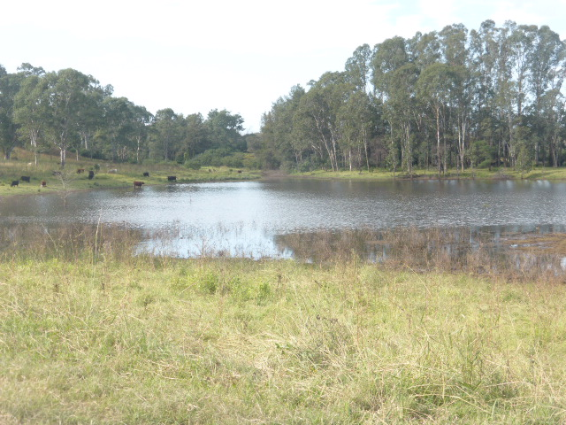
Barragal Lagoon was an important wetland for the local Dharawal people

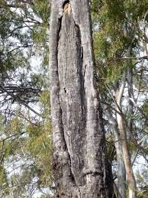
Evidence of aboriginal occupation – a scar on a tree where bark was removed for the purposes of building a simple canoe

