Workplace Health and Safety at Number 9 Dairy
All workplaces are legally obliged to care for the safety and health of their employees. Severe penalties can be imposed under workplace health and safety legislation on business managers who fail to comply with this requirement. This is one way in which the NSW state government has some control over production on Number 9 dairy.

The major areas of concern relating to workplace health and safety on Number 9 dairy are:
- Machinery usage
A wide range of machinery is used on the farm, some of which has the potential to cause catastrophic injuries
- Chemical usage
A range of chemicals are in regular use on the farm. Some of these are highly toxic and can poison workers and/or consumers if not correctly handled and applied.
- Working with large animals
Cattle are large and unpredictable animals working around them can be dangerous if proper precautions are not taken.
- Zoonoses
Some infectious diseases that affect cattle can be transmitted to humans resulting in serious human disease.

- Working in the sun
By its very nature much of the work done on the farm is conducted in the sun, this results in the risk of sun damage to the skin of workers being quite high.

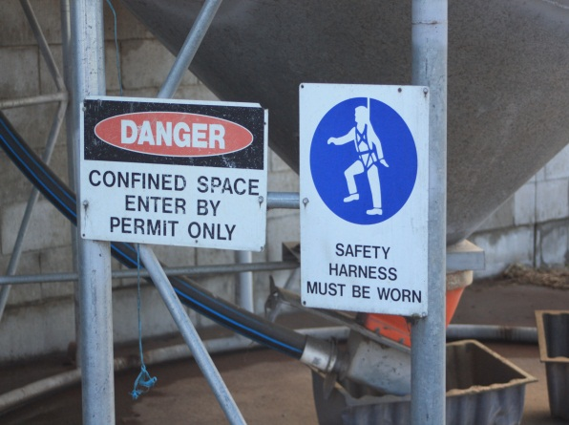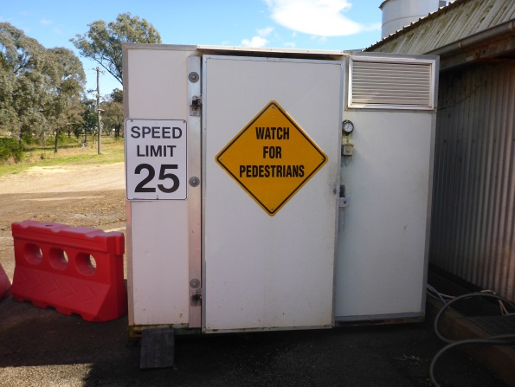
Workplace safety signs
An activity for you to complete
Draw up a table as follows. Complete it by listing issues relating to each type of workplace safety category and suggesting means by which the farm manger can ensure the safety of farm workers. Some examples have been included to get you started. You might like to have a class discussion with your teacher about these issues.

Category | Issues of importance | Management strategies to prevent injuries
Machinery safety | - tractor safety  - rollovers  - runovers  - implements  - noise | - driver training  - signage
Chemical safety | - accidental poisoning
Working with animals | - physical injury
Zoonoses | - transmission of diseases
Working in the sun | - sunstroke
Miscellaneous | - barbed wire fences

