Fodder Cropping at Number 9 Dairy
Because pasture production is not consistent throughout the year, and because of the high nutrient demand of lactating cows, supplementary feeding of the cows is a regular feature of herd management. Milking cows are fed a high energy pelletised ration at each milking. They may also be fed silage in a feed pad near the dairy shed when pasture growth is limited by cold and or dry weather.
To make silage maize (corn) crops are grown on river flats near the Nepean River on the Menangle side of the property. A hybrid maize variety (Pioneer 118 day) is chosen as produces a large amount of vegetative growth. Yields of approximately 30 tonnes per ha of dry matter can be expected. The maize is planted in late spring and harvested with a silage harvester around mid autumn when the grains are approaching maturity. The entire plant is chopped into small pieces and then stored in pits that have been dug into hillsides on the farm. The chopped maize is compacted and then covered with plastic sheeting. This keeps the material free of oxygen and it ferments anaerobically, preserving the green material to produce silage. The silage is fed to the cows using a front end loader to remove it from the pits. It is high in energy and the cows quickly become accustomed to eating it.
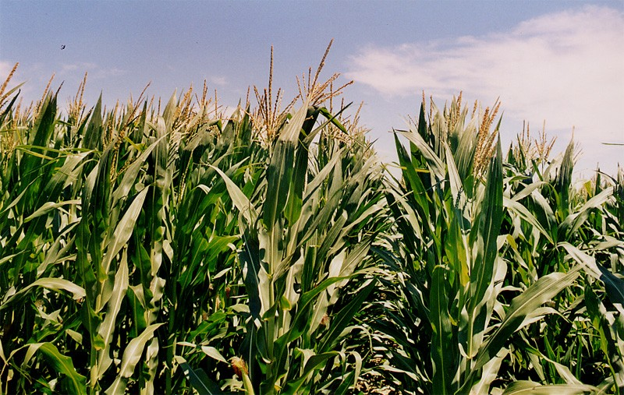
A standing crop of maize

You can see silage being made from maize here:
http://www.youtube.com/watch?v=W7_T_niPReA

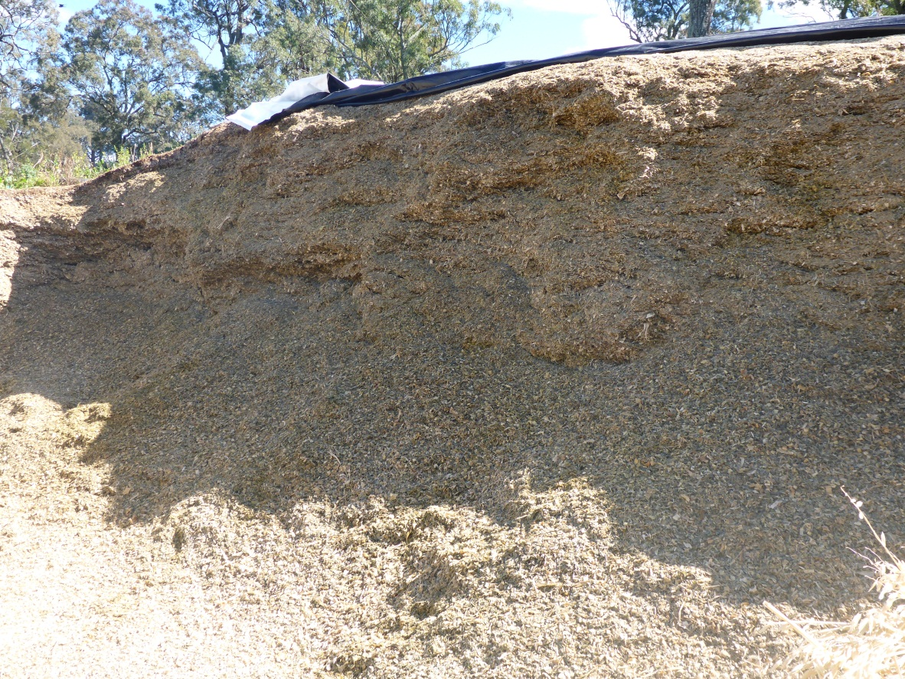
Maize silage in an opened pit

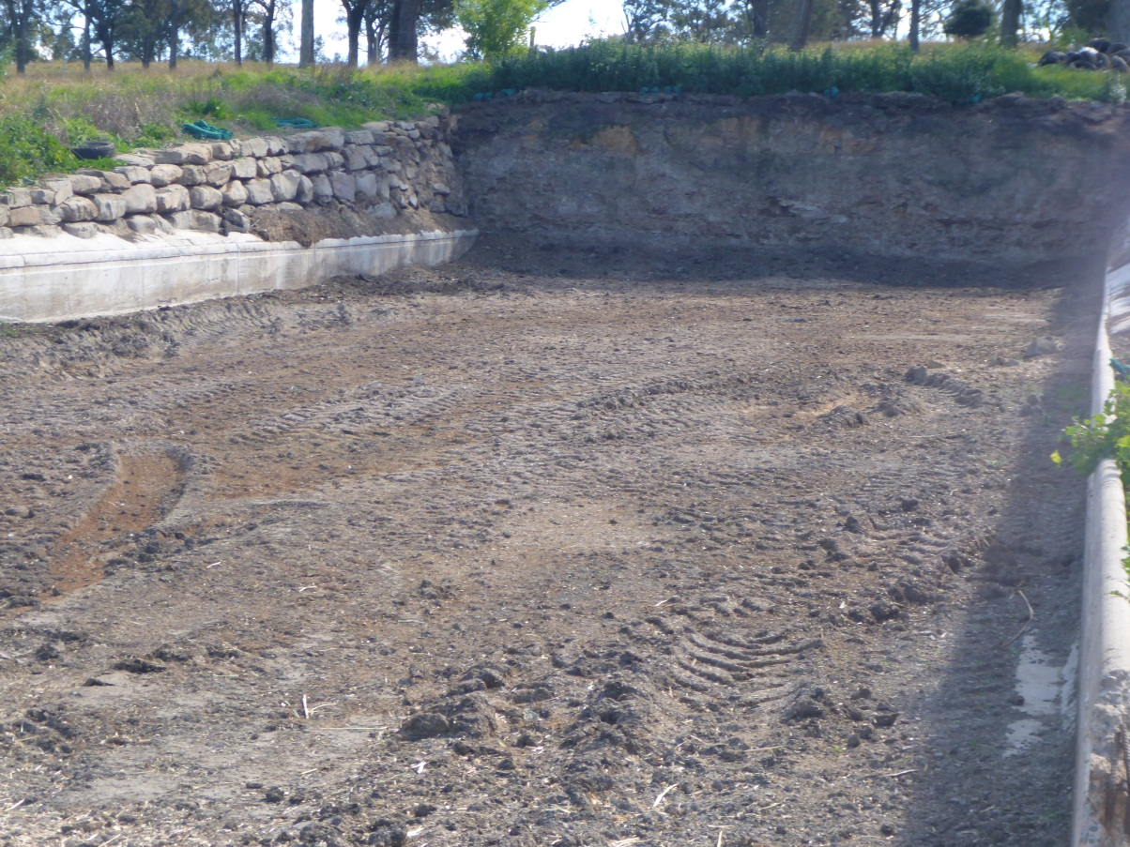
An empty silage pit
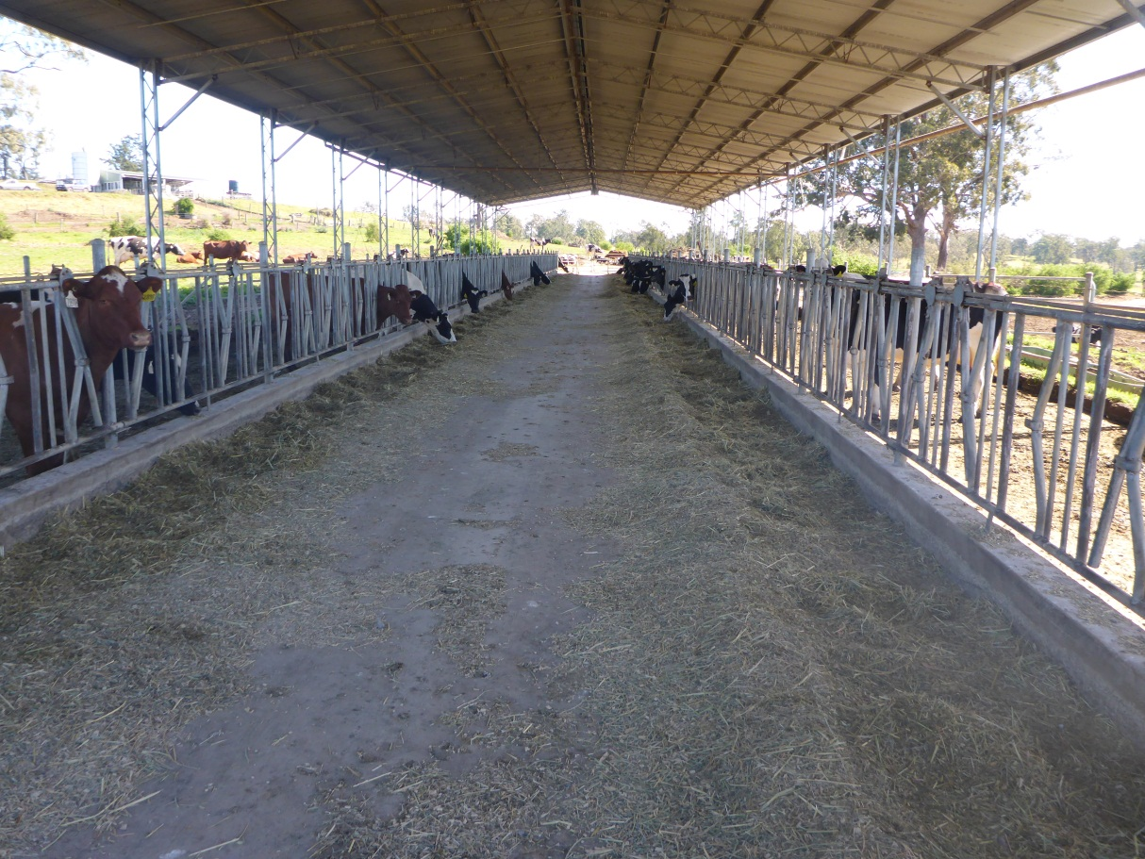
Cows eating silage in a feed pad
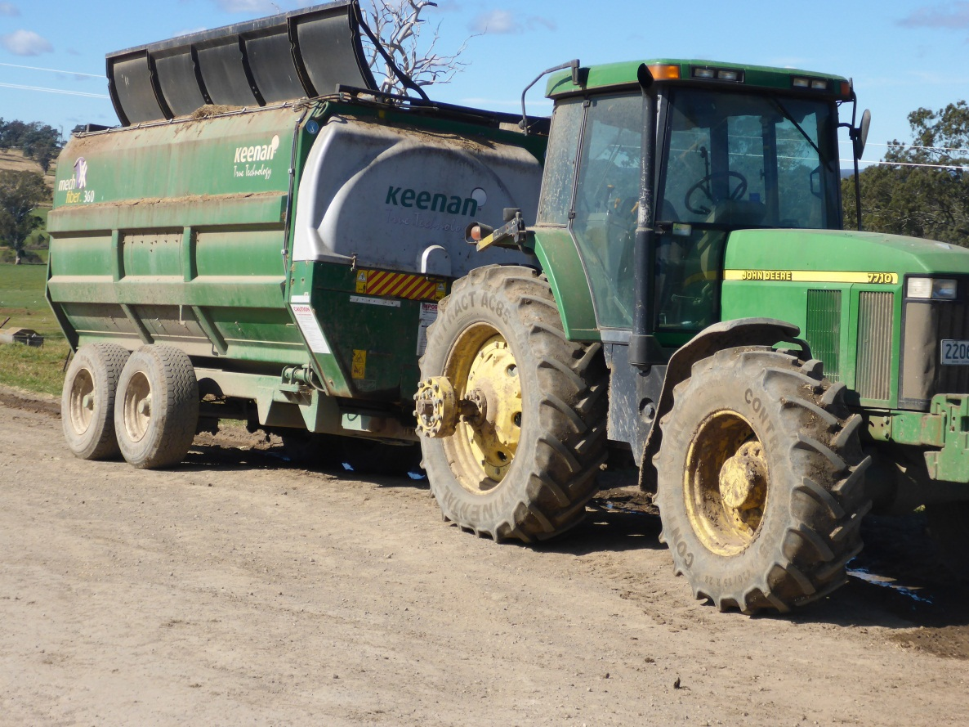
Machinery used to deliver silage to the feed pad
Sometimes silage is made from excess pasture growth in the spring to autumn period. This silage is made in the form of round bales that are wrapped in a plastic film to make them airtight and allow the material to ferment in the normal way.
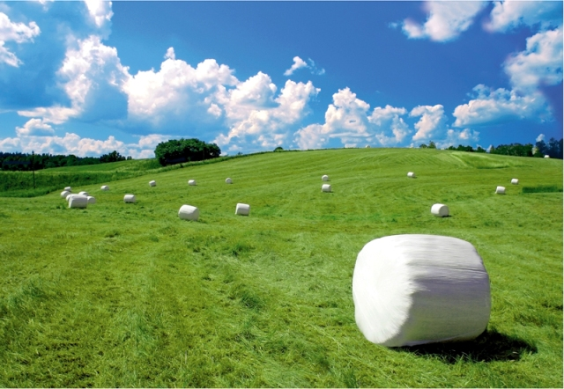
Silage made from pasture

Excess pasture can also be preserved in the form of hay.
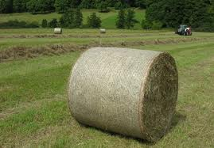
Hay being made from pasture
Activities for you to complete
- Account for the choice of maize as a crop from which to make silage at Number 9 dairy.
- Compare maize silage, hay and pelletised feeds as alternative sources of supplementary feed for dairy cattle.

