The cattle at Elizabeth Macarthur Agricultural Institute (EMAI)
- Cattle breeds and numbers
Currently, (May 2020) the herd is composed of a number of breeds as follows:
- 100 Angus cows
- 130 Wagyu cows
- 120 Shorthorn cows
- 120 Charolais cows
- 90 Hereford cows
Additionally, there are a total of 22 bulls on the farm comprising each of the above five breeds in numbers that allow for mating of all cows.
There are also calves at foot on many of the cows and weaned steers and heifers on the farm too.

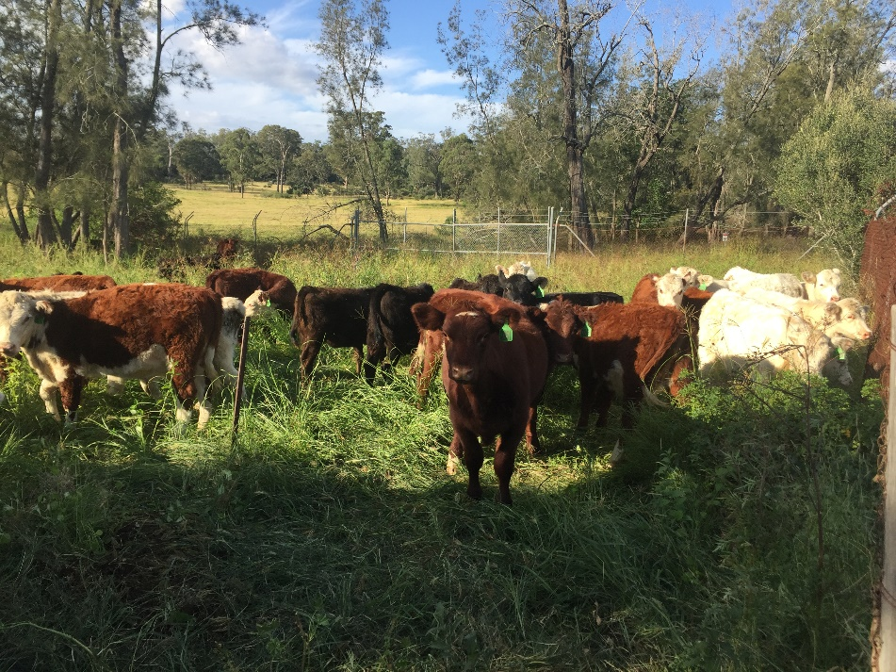
Weaner cattle at EMAI
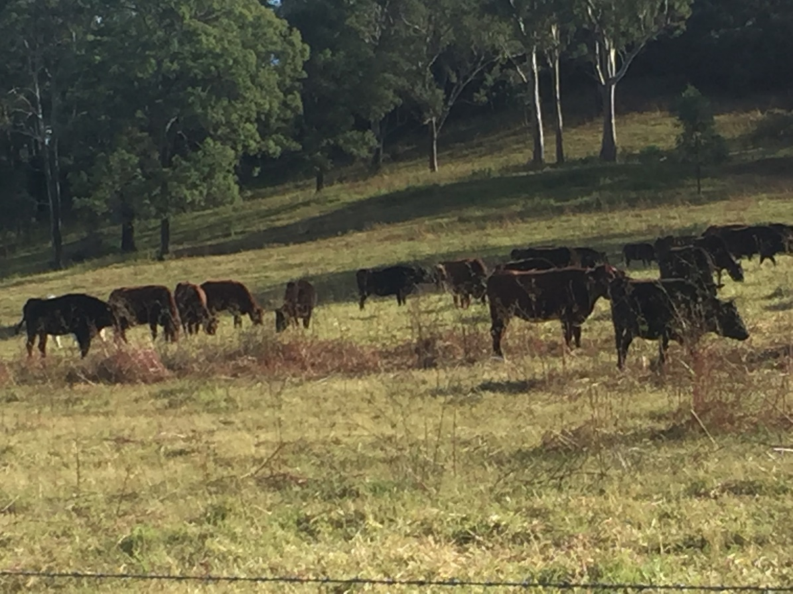
Cattle grazing on naturalised pasture at EMAI

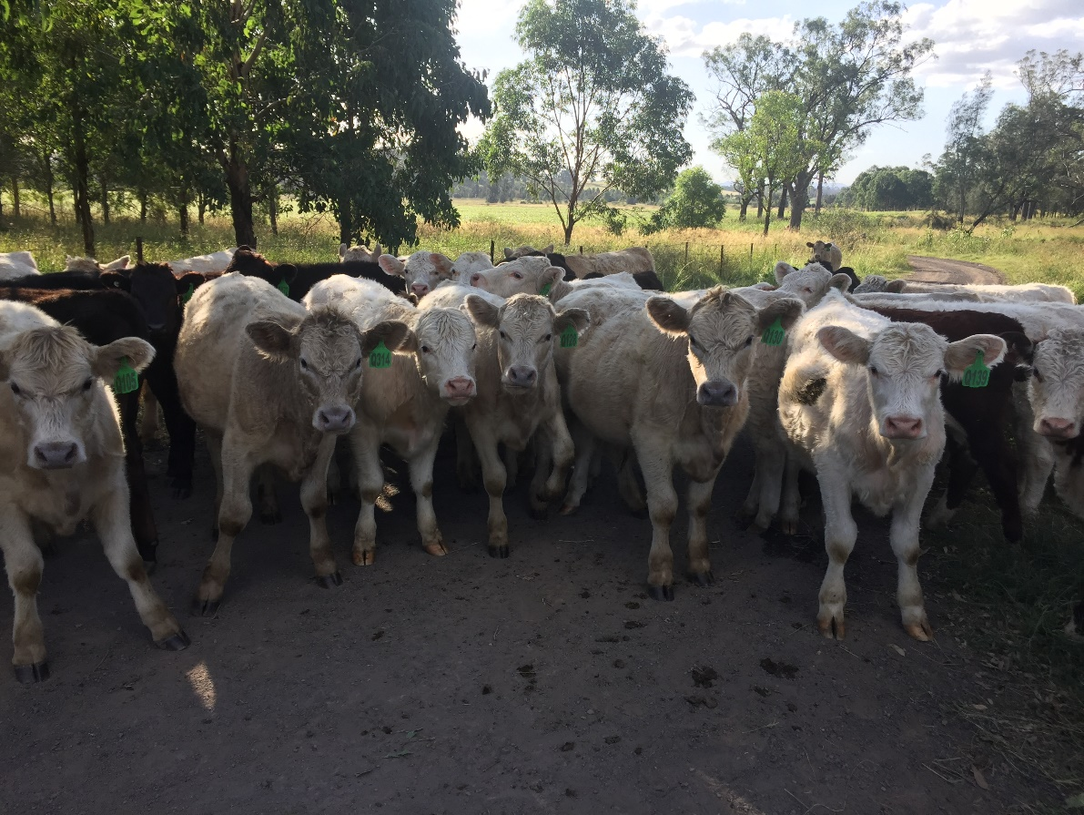
More weaner cattle at EMAI
- Breeding program
While the cattle on the farm are managed as if they were purely a commercial herd, they are in fact a component in a major genetic research program being conducted at various sites across NSW by the NSW Department of Primary Industries (DPI). This is a 10- year long project. In the first 5 years the herds will be kept as pure bred cattle but grazed side by side so that they are exposed to the same environmental conditions. Accurate records of calving rates, birth weights, growth rates and body condition will be kept so that comparisons can be made between the performance of the various breeds under the same conditions at a number of locations with different climatic conditions. During the second five-year period the animals will be cross bred between the various breeds so that data can be collected to assess the performance of the various crosses under a range of environmental conditions.

- Marketing of the cattle
Only the male offspring are sold (as steers after being castrated at an early age). They are grown on farm at EMAI to a weight of approximately 400 kg then transferred to Tullimba feedlot in northern NSW to be finished so that they meet the specifications for various beef markets. The Tullimba feedlot is owned by The University of New England and is itself a major research facility. You can find out more about it here:
https://www.une.edu.au/about-une/faculty-of-science-agriculture-business-and-law/school-of-environmental-and-rural-science/facilities/rural-properties/tullimba
It is here that the final stage of the research begun at EMAI (and on other NSW DPI properties) is completed.
Further information about this research project can be found here:
https://www.theland.com.au/story/6306397/spring-joining-the-start-of-ambitious-multi-breed-ebv-research/

- Herd Health
As on any farm that raises animals, the management at EMAI are responsible for ensuring the safety and welfare of all animals under their care. This includes taking steps to prevent disease that might be expected to occur on the farm and for the timely treatment of any disease outbreaks that do occur.
(contiued on the next page)

The diseases that are most likely to occur on the farm include:
- Clostridial diseases (pulpy kidney, tetanus, black disease, malignant oedema and blackleg)
- Leptospirosis
- Bovine ephemeral fever (three-day sickness)
- Botulism
- Bloat
The major parasitic diseases likely to be encountered are:
- Various roundworm species
- Lice
- Ticks

The management of these potential health issues in the cattle at EMAI entails:
- Routine vaccination of calves at around 6 weeks of age with 7 in 1 vaccine to prevent the clostridial diseases and leptospirosis. A second booster dose is given at 12 weeks of age to confer complete immunity against these diseases. An annual booster dose then ensures the continuation of the immunity.
- Drenching of all calves and cattle. Drenches can be administered orally using a drench gun or as a ‘pour on’ whereby the chemical is applied along the back of the animal. At EMAI the drenches chosen for use control both internal parasites (ie roundworms) and external parasites (ie lice and ticks). Care is taken to rotate the drenches so as to avoid the possibility of resistance developing to them in the parasite population.

