Sustainability at Elizabeth Macarthur Agricultural Institute (EMAI)

Sustainability has become the catch-cry of modern farming. In recent years most Australian farmers have adjusted their farming practices in an attempt to improve the environmental and economic sustainability of their farming systems.
Sustainable farming systems are generally agreed to have the following characteristics:
- they are profitable
- they conserve natural resources (especially soils, waterways and vegetation)
- they recycle nutrients through the farming system
- they minimise energy usage
- they attempt to repair past environmental damage (eg soil erosion, salinity, acidification, soil structural decline, vegetation decline)
- they minimise the usage of chemicals

It is important to note that sustainable agriculture encompasses both environmental and economic considerations. At EMAI a range of farming practices have been adopted in order to improve the sustainability of the beef production enterprise.
Managing the soils
Soils are the basis of successful production on any farm that relies on the growth of pastures and/or crops. Managing them sustainably is crucial to maintaining high levels of production into the future. The practices adopted at EMAI that contribute towards sustainability include:
- Using the land according to its capability
A land capability assessment of the entire farm was conducted some years ago. This identified four distinct land capability units on the farm.
- Class 2 land is found along the flood plain of Navigation Creek which runs roughly through the centre of the farm. This land has deep alluvial soils and is relatively flat, meaning that it can be cultivated on a regular basis. It is on these soils that the majority of the improved pastures on which the cattle graze are grown. Fodder cropping also occurs on this land.
- Class 3 land is also found along the floodplain. It is somewhat sandier than the class 2 land and is also used for the production of improved pastures
- Class 4 land is found on the hillsides on the farm. This land should only be cultivated infrequently for cropping or pasture establishment. Some class 4 land is used for growing winter crops such as oats. Most, however, is not cultivated at all and left to grow native and naturalised pasture species on which cattle graze.
- Class 5 to 8 land is located on the steeper slopes and gullies on the farm. It is not cultivated at all and is used to grow native and/or naturalised pastures on which the herd occasionally graze.

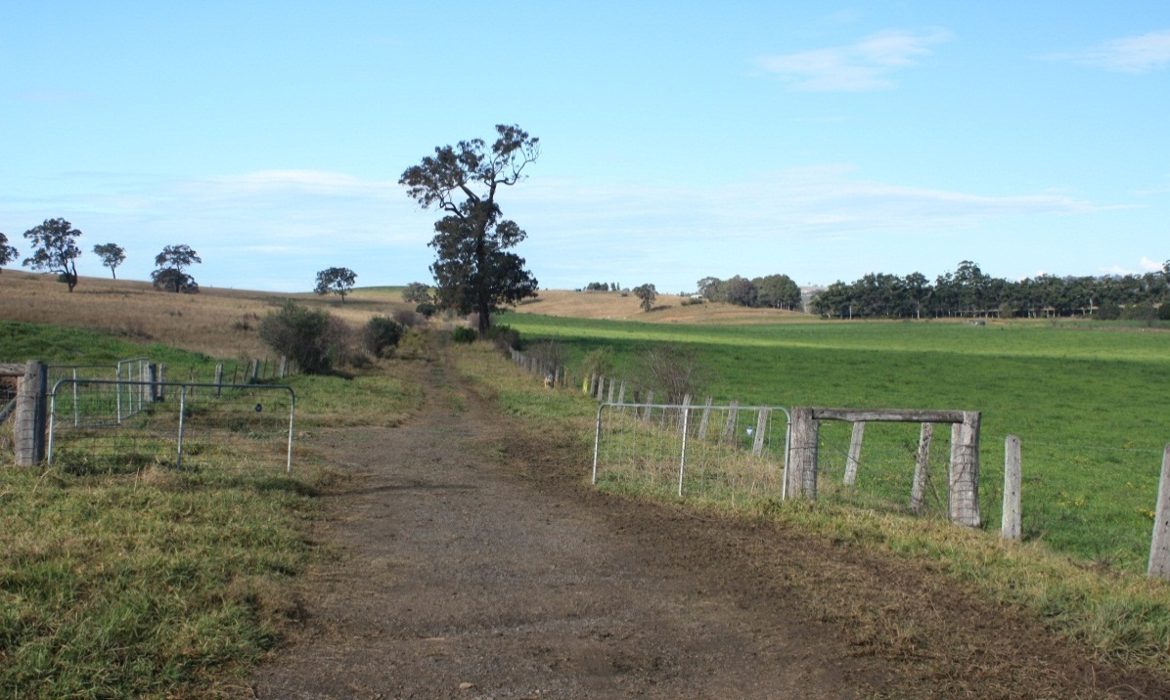

Class 2 land on the creek flats to the right of the photo graduating to class 4 land on the left hand side.

- The use of direct drilling in pasture establishment
Kikuyu grass forms the basis of summer pasture production on the farm. It is highly productive between the months of November and March, provided rainfall is high or it is irrigated. In order to provide winter feed for the herd cold tolerant species such as perennial ryegrass and white clover are direct drilled into the kikuyu paddocks during the months of April and May. The kikuyu is grazed heavily and/or mulched before planting the seed in order to reduce competition for the new seedlings and so ensure successful establishment of them.
The principal advantages of direct drilling these winter pasture species into the existing kikuyu pastures (as opposed to cultivating the soil several times prior to planting) are:
- production from the kikuyu pastures is maintained until seeding time
- destruction of soil structure (as a result of cultivation) is avoided
- there is a saving on fuel and labour costs
- the level of compaction of the soil is reduced

- The use of chemical fertilisers
In every animal that leaves the farm nutrients (such as nitrogen and phosphorus) that were originally in the soil are exported from the farm. In order to maintain pasture and crop (and hence beef) production these nutrients must be replaced. At EMAI this is primarily achieved by the use of chemical fertilisers. A typical fertiliser program for the main pasture paddocks is as follows:
Fertiliser type | Nutrients supplied | Application rate | Timing
Hi-Fert blend (15:8:6) | N, P K | 150 Kg/ha | Spring
Urea | N only | 100Kg/ha | After each 2nd grazing
Managing the water
A reliable supply of high quality water is required on all cattle farms. At EMAI water is primarily required to:
- provide drinking water for the cattle
- mix any chemical sprays that may be used on the crops and/or pastures
Sources of water on the farm include:
- farm dams of various sizes
- the local town water supply
- rain water collected from the rooves of buildings
- recycled effluent from the Camden West sewerage works
Practices that have been adopted to maintain the quality of the water supplies on the farm include:
- Limiting access by stock to dams
When livestock are given free access to dams they tend to muddy the area around the edges, increasing the turbidity of the water. To avoid this, wherever possible, drinking water is provided to stock via drinking troughs supplied via the town water supply. Electric fences are often placed around the perimeter of dams to prevent access by stock. These measures help maintain the quality of the water in the farm dams.

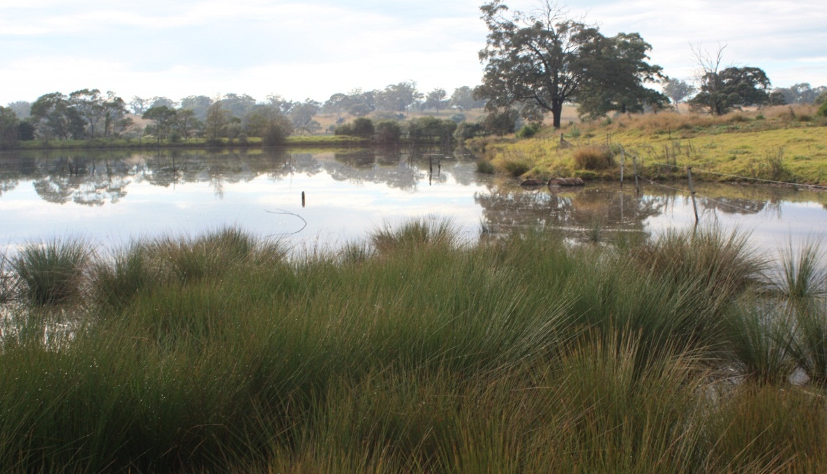
Permanent and electric fencing is used to exclude stock from farm dams

- Retaining riparian vegetation
A riparian zone is the area of land immediately adjacent to the banks of a waterway. This vegetation plays a vital role in stabilising the stream banks and preventing them eroding into the water. Streams with eroded banks are often highly turbid so that light does not penetrate into their depths. The effect of this is to reduce the growth of water plants which form the basis of the foodweb in the waterway. In turn, the fauna that is dependent on these plants is affected and there is a consequent loss of biodiversity in the water.
At EMAI the banks of Navigation Creek have been fenced to exclude stock and, where necessary, local species of plants have been used to revegetate these areas.

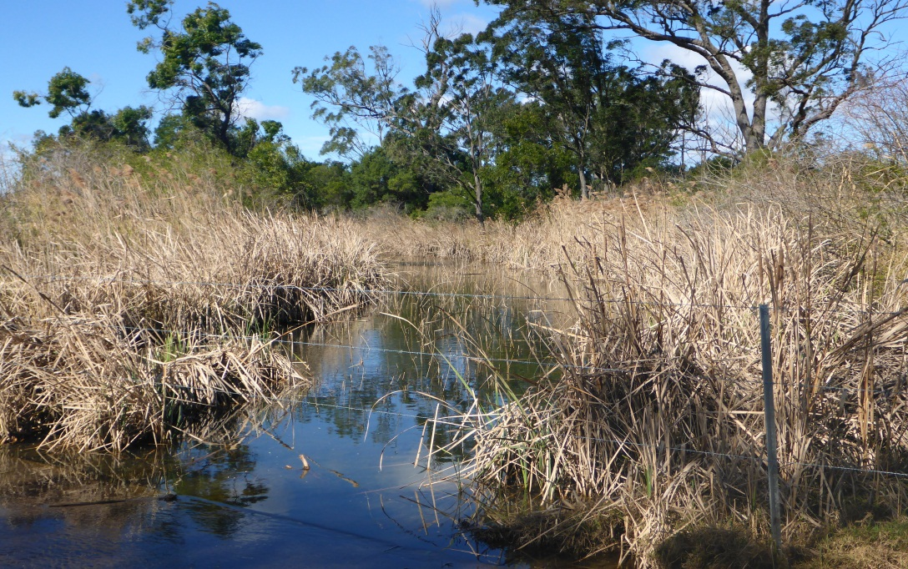

Fenced riparian vegetation along Navigation Creek
Managing the wildlife
Wildlife management is an integral component of the overall focus on sustainability at EMAI. Having a high level of biodiversity on the farm contributes to the management of a number of pest species that may impact on overall farm production. The principal wildlife management programs currently being implemented on the farm are outlines below.

- Preservation of mature living trees
The three most common tree species found on the farm are Grey Ironbark (Eucalyptus crebra), Forest Red Gum (Eucalyptus tereticornis) and Grey Box (Eucalyptus molluccana). Mature and dead specimens of these trees often contain hollows that are created as a result of termite attack. These hollows are the nesting sites of the Lace Monitor (or Tree Goanna) which is an important predator of rabbits. Rabbits can cause significant damage to pastures and hence reduce production. Encouraging and protecting lace monitors provides a natural and basically free means of biological control of rabbits on the farm.

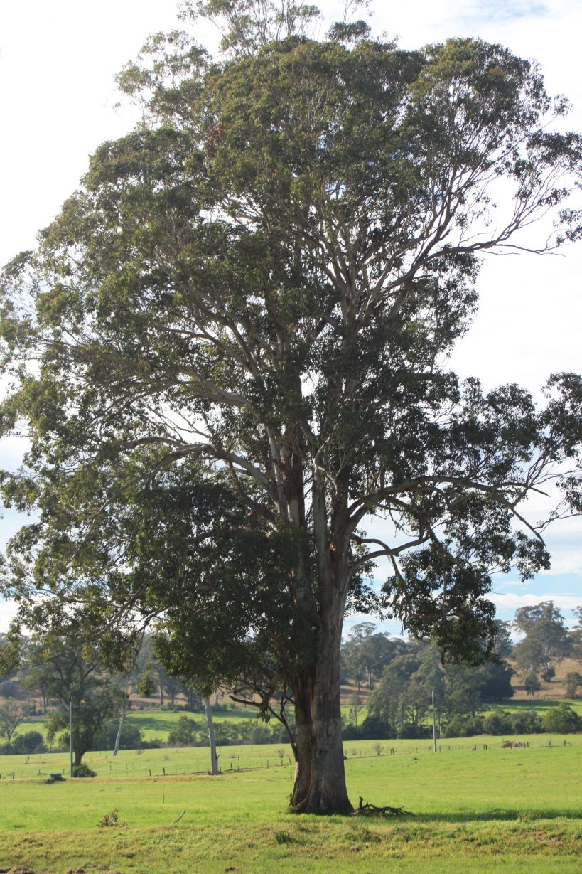
A mature Forest Red Gum
- Preservation of dead trees
Fourteen of Australia’s raptorial bird species (birds that hunt and kill other animals) have been observed in recent years at EMAI. Like goannas, these birds prey on rabbits and play a part in keeping their numbers at a low level. A number of these raptors breed on the farm. They like to nest high above the ground in mature living or dead trees. Leaving dead trees where they stand is one means of providing these birds with suitable nesting sites.
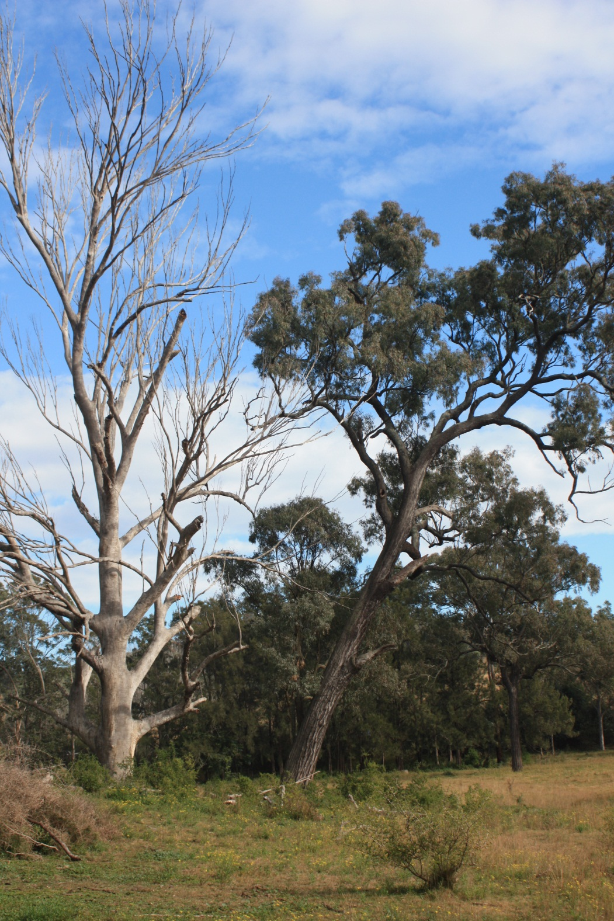
Trees like these are important nesting sites for goannas and various bird species

- Protection of known raptors nesting sites
Lace Monitors are able to climb high into trees and eat the young of raptorial bird species. In order to prevent this from happening some trees in which raptors have been known to nest have been fitted with a collar of smooth sheet metal in order to stop the lace monitors from climbing the tree and raiding the bird nest in it.
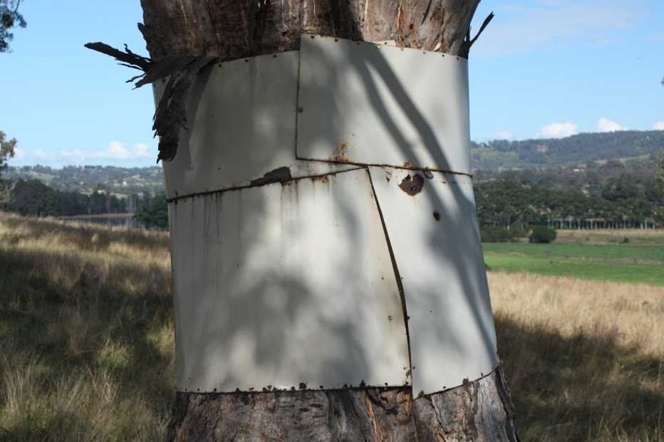
Metal guard to prevent Lace Monitors climbing the tree
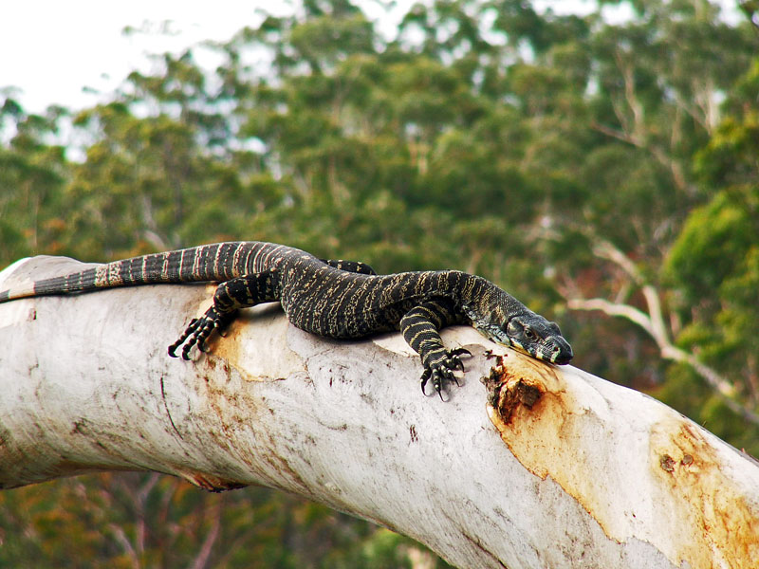
A Lace Monitor resting on a tree branch

- Islands in farm dams
The Straw-necked Ibis is a resident species on the farm. They play an important role in the control of insects such as grasshoppers, locust and beetles which eat pastures on the farm.
To assist in providing breeding sites and habitat for the straw-necked ibis small islands have been created in some farm dams. The ibises build their nests in the reeds which surround these islands.

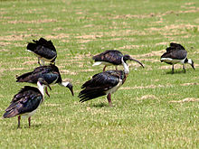
Straw-necked Ibis grazing on pasture

- Preservation of Native Blackthorn ( Bursaria spinosa)
Native blackthorn is a small to medium sized shrub that grows as an understory plant in open forested areas. It is frost, drought and wind tolerant and is very common in uncleared areas on the farm. The nectar in its flowers is an important source of food for some species of parasitic wasps (and other insects such as butterflies). These wasps parasitise the larvae of various species of beetles which damage pastures and eucalyptus trees. Preservation of native blackthorn increases the populations of these predatory wasps and thus assists in the biological control of theses damaging beetles.
Native blackthorn, being a prickly species, is also a favoured nesting site for various types of small birds.
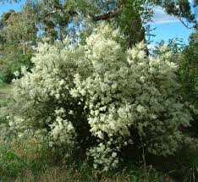
Native blackthorn in full flower

- Creation of vegetation buffer zones along Navigation Creek
The riparian zone vegetation that was discussed in the section on managing water on the property also plays a role on maintaining wildlife on the farm. It provides food, shelter and nesting sites for many birds, reptiles and insects.

