Fodder cropping at Elizabeth Macarthur Agricultural Institute (EMAI)
Because pasture production is not consistent throughout the year, and because of the high nutrient demand of lactating cows with calves at foot and of growing animals, supplementary feeding is a regular feature of herd management. The cattle are commonly fed silage or hay when pasture growth is limited by cold and/or dry weather.
To make silage maize (corn) crops are grown on river flats near the Nepean River on the Menangle side of the property. A hybrid maize variety (Pioneer 118 day) is chosen as it produces a large amount of vegetative growth. Yields of approximately 30 tonnes per ha of dry matter can be expected. The maize is planted in late spring and harvested with a silage harvester around mid-autumn when the grains are approaching maturity. The entire plant is chopped into small pieces and then stored in pits that have been dug into hillsides on the farm. The chopped maize is compacted and then covered with plastic sheeting. This keeps the material free of oxygen and it ferments anaerobically, preserving the green material to produce silage. The silage is fed to the cows using a front end loader to remove it from the pits. It is high in energy and the cows quickly become accustomed to eating it.
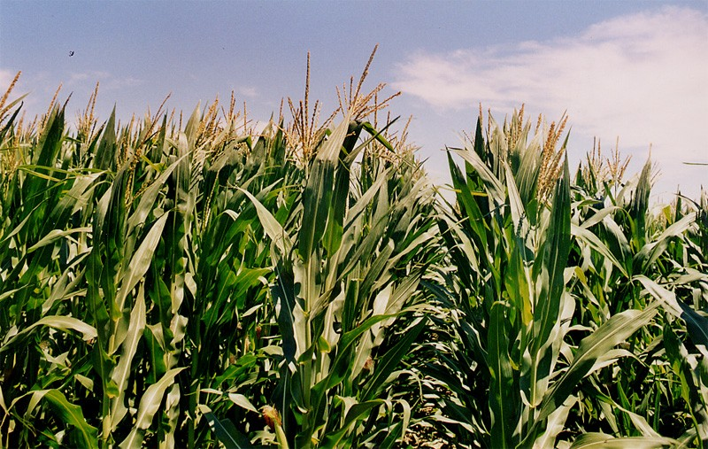
A standing crop of maize

You can see silage being made from maize here:
http://www.youtube.com/watch?v=W7_T_niPReA

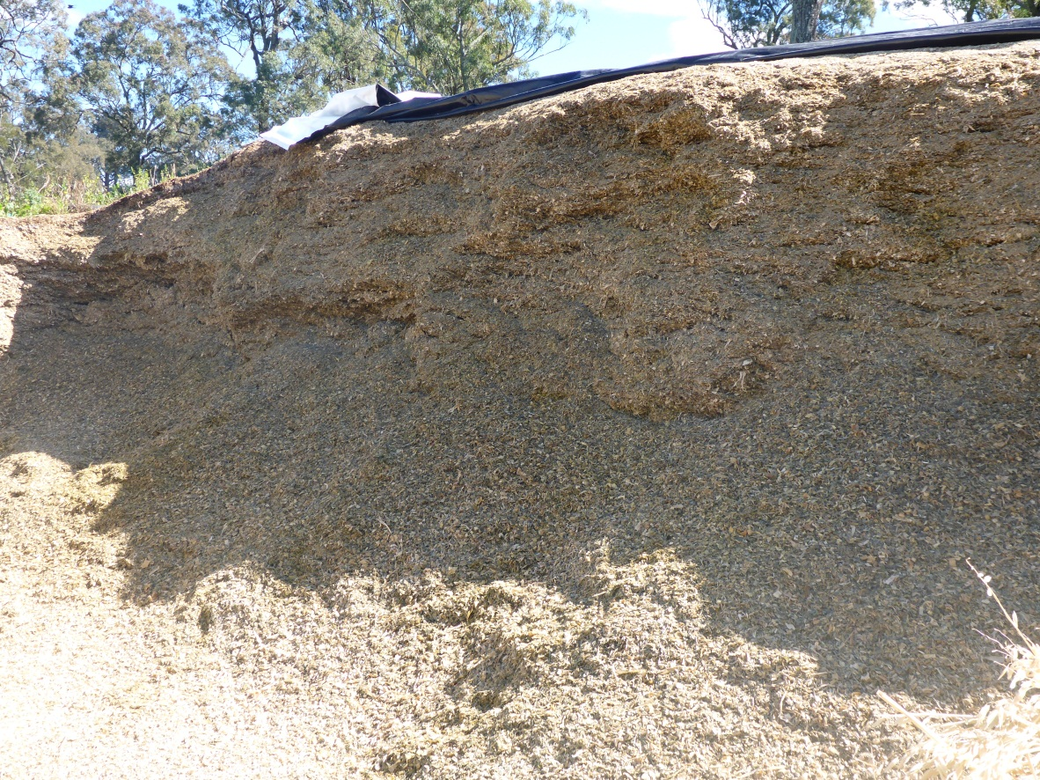
Maize silage in an opened pit

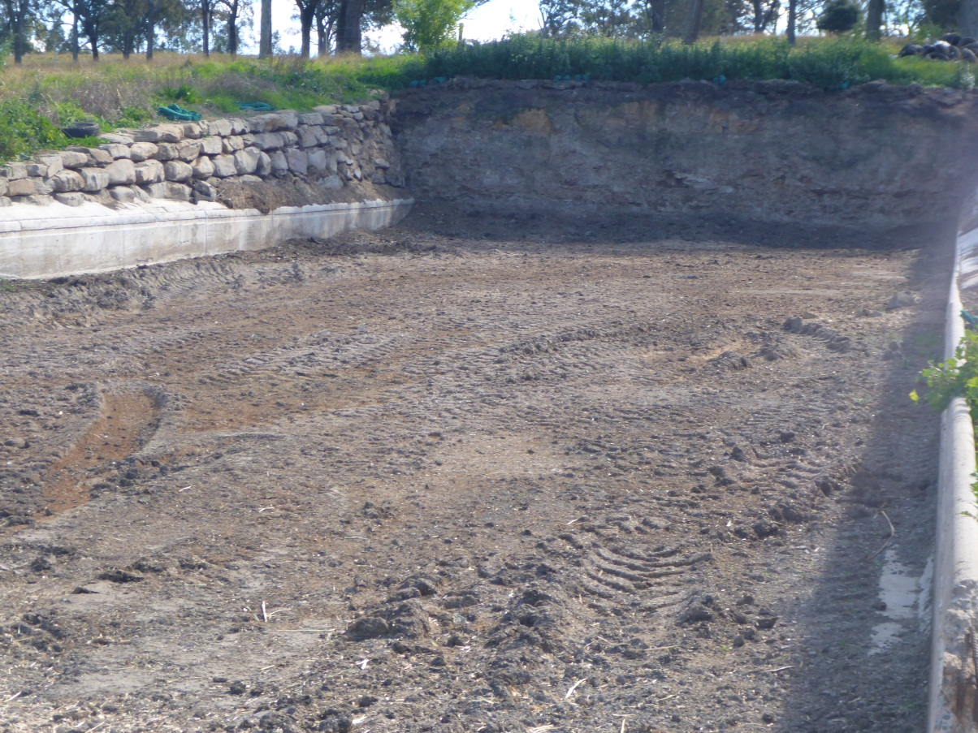
An empty silage pit

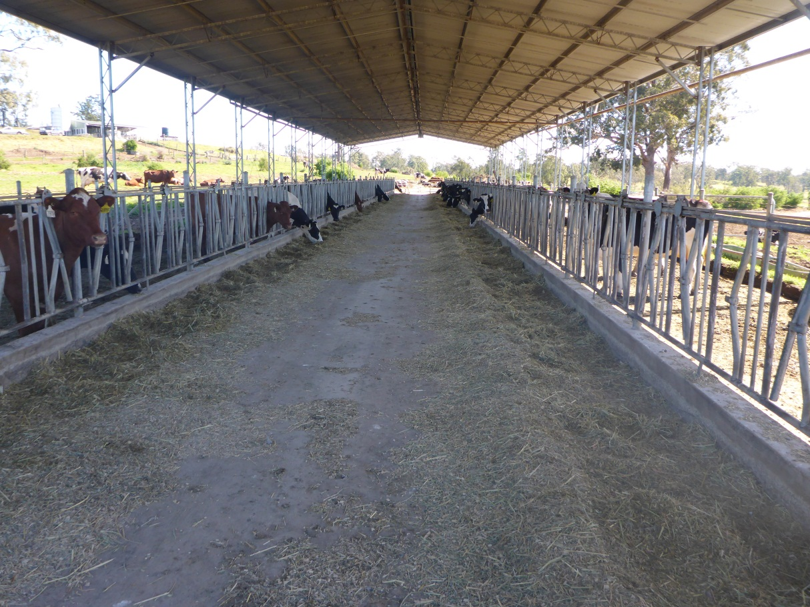
Cows eating silage in a feed pad
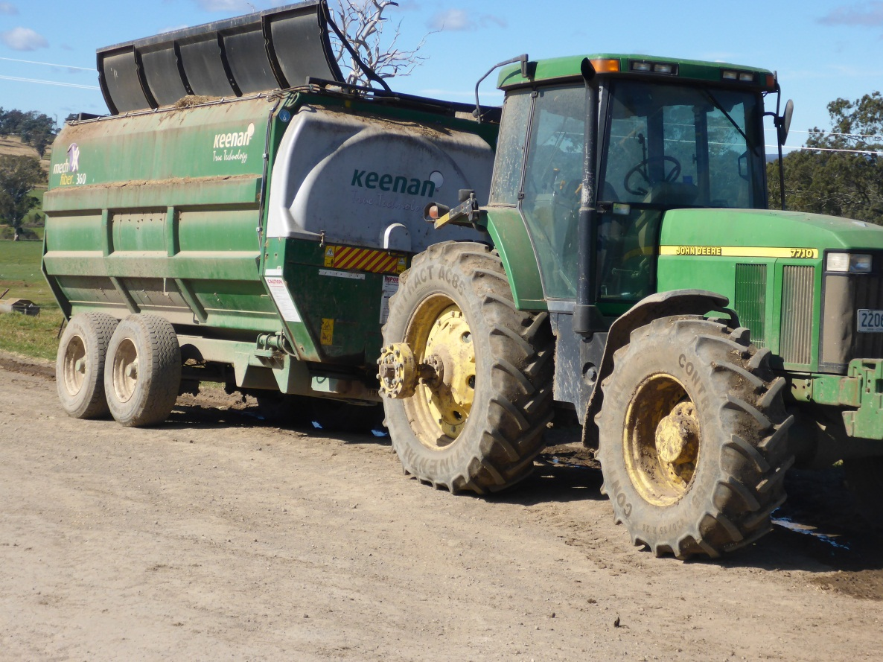
Machinery used to deliver silage to the feed pad
Sometimes silage is made from excess pasture growth in the spring to autumn period. This silage is made in the form of round bales that are wrapped in a plastic film to make them airtight and allow the material to ferment in the normal way.
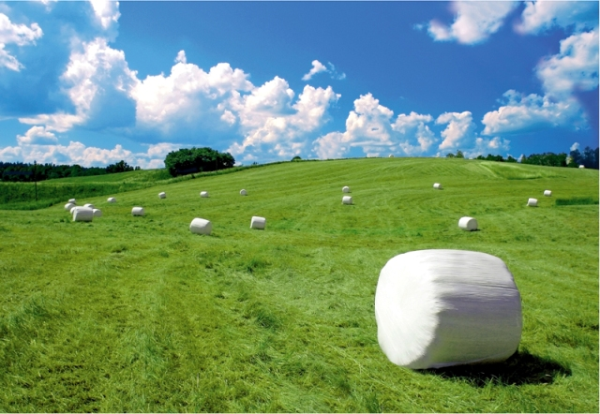
Silage made from pasture
Excess pasture can also be preserved in the form of hay.

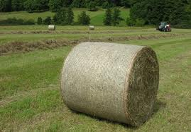
Hay being made from pasture

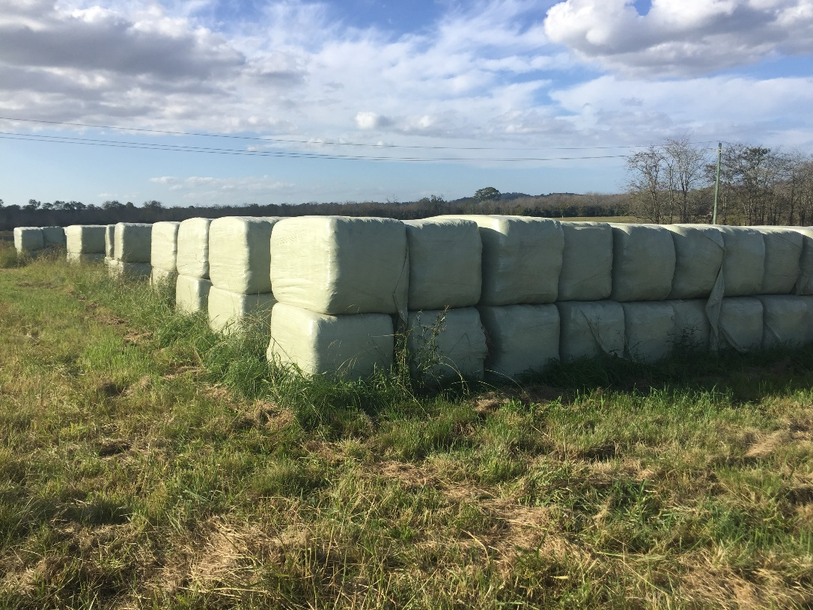
Hay stored for use in times of pasture shortage
Other crops grown on the farm include sorghum and oats. The sorghum is grown as a summer fodder crop, being planted in mid-late spring and grazed from mid – late summer. It can also be used as an alternative to maize for silage making.
The oats is grown as a winter forage crop. It is planted in the autumn months and is grazed from mid-winter into spring. It can also be used to make hay if pasture growth is adequate and it is not needed for grazing by the cattle.
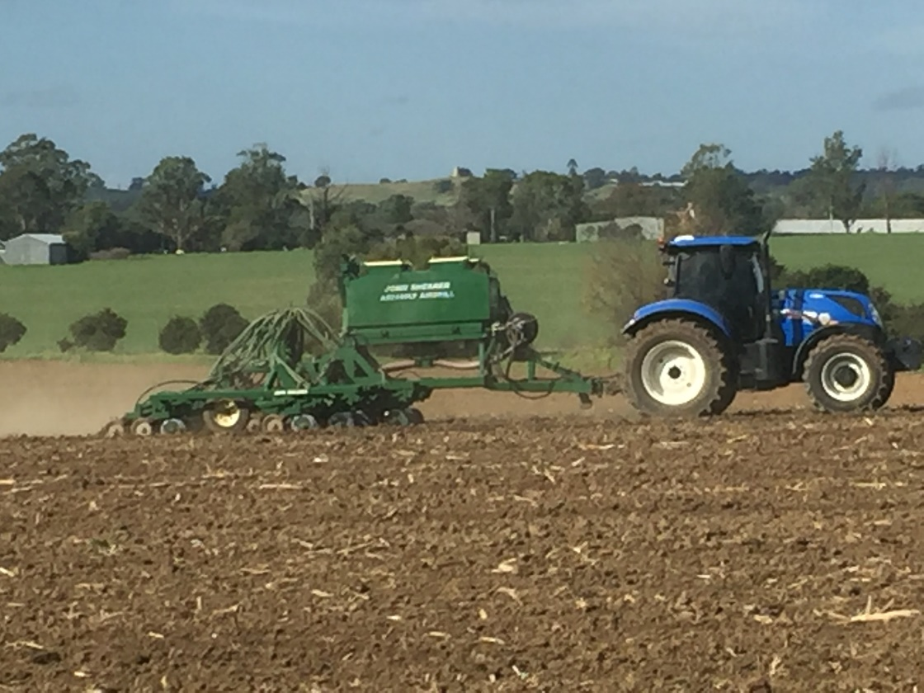
Winter oat crop being seeded into prepared land

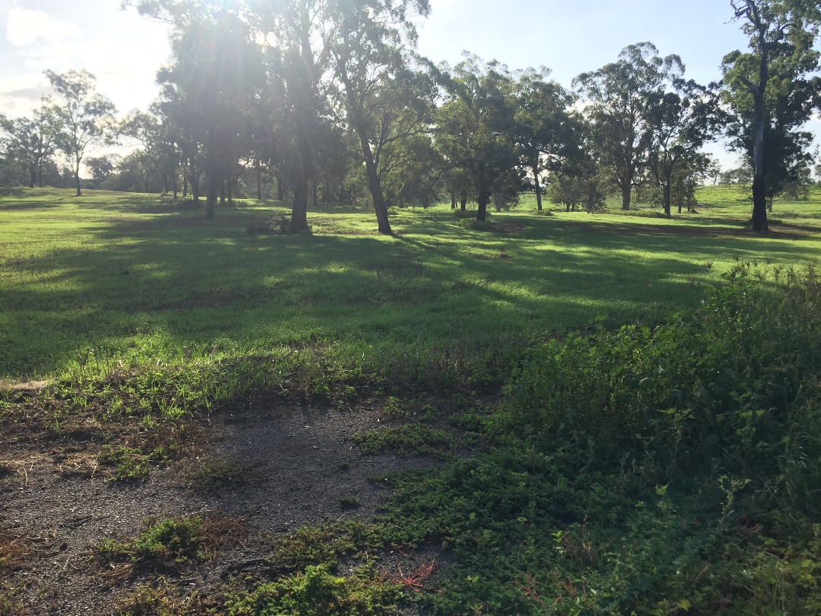

Young oat crop growing on the farm

