Preliminary HSC farm case study
Beef cattle
Elizabeth Macarthur Agricultural Institute
Menangle NSW

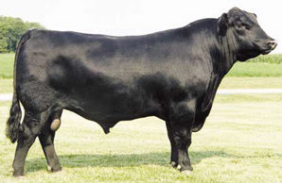

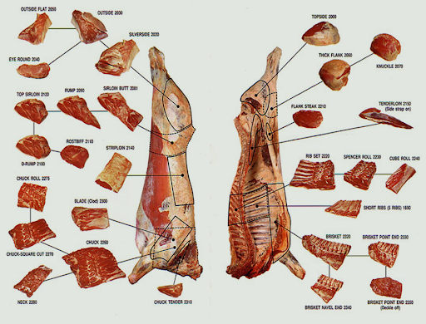

General Farm Information

Owners Name: _________________________________________

Managers Name: _________________________________________

Property Name: _________________________________________

Farm Area: __________________ hectares

Location of Farm ___________________________________________________________________
___________________________________________________________________________

Farm History
Outline the history of land use on the property

___________________________________________________________________________
___________________________________________________________________________
___________________________________________________________________________
___________________________________________________________________________
___________________________________________________________________________
___________________________________________________________________________
___________________________________________________________________________
___________________________________________________________________________
___________________________________________________________________________
______________________________________________________________________________________________________________________________________________________

Physical Resources

1. Climate
Describe the climate of the Elizabeth Macarthur Agricultural Institute
___________________________________________________________________________
___________________________________________________________________________
__________________________________________________________________________

2. Water Resources

Sources of water ___________________________________________________________
___________________________________________________________________________

Availability of water _________________________________________________________
___________________________________________________________________________

Quality of water ____________________________________________________________
___________________________________________________________________________
___________________________________________________________________________
Uses made of the water ________________________________________________

3. Native Vegetation

Describe the vegetation types that originally existed on the farm.
___________________________________________________________________________
___________________________________________________________________________
___________________________________________________________________________
___________________________________________________________________________
Describe the current vegetation status of the farm __________________________________________________________________
___________________________________________________________________

4. Topography
Describe the topography of the farm
______________________________________________________________________________________________________________________________________

Explain how land use on the farm is influenced by topography.
___________________________________________________________________________
___________________________________________________________________________
___________________________________________________________________________

5. Soils
Analyse the soils by performing simple physical and chemical tests in the field.

Soil type 1 _____________________________________________________

Soil texture ________________________________________________________________
Soil structure _______________________________________________________________
Soil colour _________________________________________________________________
Soil pH ____________________________________________________________________

Soil type 2 ________________________________________________________________

Soil texture ________________________________________________________________
Soil structure _______________________________________________________________
Soil colour _________________________________________________________________
Soil pH ____________________________________________________________________

Techniques used to maintain soil fertility
___________________________________________________________________________
___________________________________________________________________________
___________________________________________________________________________
___________________________________________________________________________
___________________________________________________________________________

Capital Resources and Improvements

Machinery ________________________________________________________________
___________________________________________________________________________

___________________________________________________________________________
Buildings __________________________________________________________________
___________________________________________________________________________
Fencing ___________________________________________________________________
___________________________________________________________________________

Other _____________________________________________________________________
___________________________________________________________________________

Human Resources
___________________________________________________________________________
___________________________________________________________________________
___________________________________________________________________________

Pasture Production

Natural Pasture
Area involved _____________ hectares

Types and varieties _________________________________________________________
___________________________________________________________________________
______________________________________________________________________________________________________________________________________________________

Management ______________________________________________________________
___________________________________________________________________________
______________________________________________________________________________________________________________________________________________________

Improved Pasture
Area involved ___________ hectares

Types and varieties _________________________________________________________
___________________________________________________________________________
______________________________________________________________________________________________________________________________________________________

Management ______________________________________________________________
___________________________________________________________________________
______________________________________________________________________________________________________________________________________________________

Crop Production

Area involved ___________ hectares

Types and varieties _________________________________________________________
___________________________________________________________________________
______________________________________________________________________________________________________________________________________________________

Management ______________________________________________________________
______________________________________________________________________________________________________________________________________________________

Farm Animal Production
Breed(s) of animals kept. ____________________________________________________
_________________________________________________________________________________________________________________________________________________________________________________________________________________________________

Reasons for keeping these breeds ___________________________________________
_________________________________________________________________________________________________________________________________________________________________________________________________________________________________
Animal numbers
Breeding cows _______________________________________________________
Replacement heifers __________________________________________________
Steers ______________________________________________________________
Bulls ________________________________________________________________

Animal productivity
Growth rate (Kg/steer/day). ______________________________________
Number of steers turned off __________________________per year
Usual destination (sale method) ________________________________________
Average liveweight at sale ______________ kg
Average price received last year __________________ (c/kg liveweight)

Quality of animal products
Give two examples of specifications for this product to qualify for grading by Meat Standards Australia (MSA).
____________________________________________________________________________________________________________________________________________________________________________________________________________________________________________________________________________________________________________ What farm strategies are employed to ensure EMAI cattle meet that standard?
________________________________________________________________________________________________________________________________________________________________________________________________________________________________________________________________________________________________________________________________________________________________________________________________________________________________________________________________________________________________________________________________________________________________________________________________________________________

Impact of Microbes /Invertebrates
Complete the following with regard to two diseases that may affect cattle on the property.
Name of disease 1 _________________________________________________________
Symptoms in cattle ___________________________________________________
Impacts on production._______________________________________________________
___________________________________________________________________________
Prevention/control measures used _______________________________________
___________________________________________________________________

Name of disease 2 _________________________________________________________
Symptoms in cattle ___________________________________________________
Impacts on production._______________________________________________________
___________________________________________________________________________
Prevention/control measures used _______________________________________
___________________________________________________________________

Complete the following with regard to two invertebrate pests (parasites) that may affect cattle on the property.
Name of an internal parasite ________________________________________________
Symptoms in cattle ___________________________________________________
Impacts on production._______________________________________________________
___________________________________________________________________________
Prevention/control measures used _______________________________________
___________________________________________________________________

Name of an external parasite _______________________________________________
Symptoms in cattle ___________________________________________________
Impacts on production._______________________________________________________
___________________________________________________________________________
Prevention/control measures used __________________________________________________________________________________________________________________________________________________

Farm Technology
Describe a recent technology that has been adopted on the farm. Outline the impacts of this technology on farm production
Description of technology ____________________________________________________
______________________________________________________________________________________________________________________________________________________
___________________________________________________________________________
Impacts of the technology ___________________________________________________________________________
___________________________________________________________________________
______________________________________________________________________________________________________________________________________________________

The Farm as a Workplace

Complete the following table with regard to four potential workplace hazards that are evident on the farm

Potential hazard category | Issues of importance | Management strategies to prevent injuries
Machinery safety
Chemical safety
Working with animals
Working in the sun

Farm Sustainability
Complete the following table with regard to issues of sustainability encountered on the farm.

Description of issues | Management practices adopted to help improve sustainability
Soils
Water
Wildlife

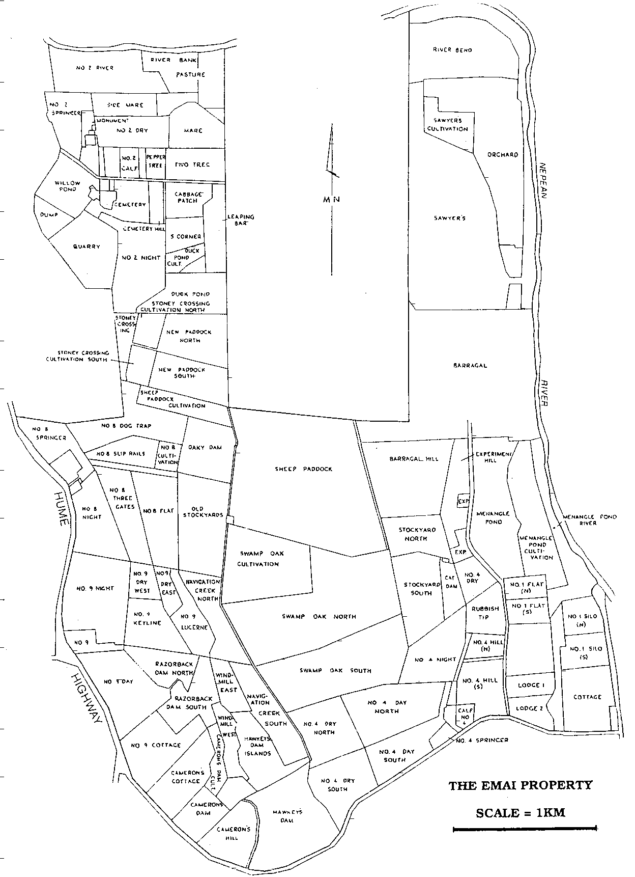

Farm map

